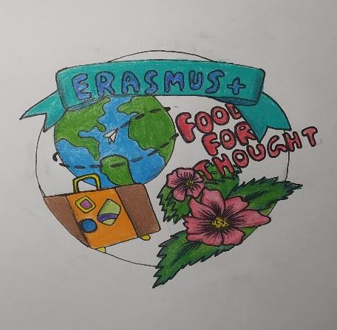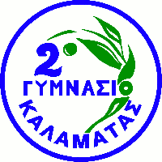

ORGANIC FOOD SURVEY
How much do you know about organic food? Answer the following questions as True or False to find out.

- Organic food is produced by methods that follow the practice of cycling resources. [ ]
- Organic farming promotes ecological balance. [ ]
- Organic farming preserves biodiversity. [ ]
- Organic farmers restrict the use of certain pesticides and fertilizers. [ ]
- EU countries, the USA, Canada, and many other countries require producers to obtain special certification to market their food as organic. [ ]
- From an environmental perspective, fertilizing, overproduction, and the use of pesticides in farming negatively affect ecosystems, soil health and biodiversity. [ ]
- Demand for organic foods is primarily driven by consumer concerns for personal health and the environment. [ ]
- Underline the types of food that are organic - fruit / vegetables / cereal / dairy products / meat / cookies (if all correct types are underlined, then the question is True). [ ]
- My parents buy organic food from the supermarket. [ ]
- Organic candies are made without the use of artificial colors, flavors, or sweeteners. [ ]
- Organic fruit and vegetables spoil faster. [ ]
- Organic meat comes from animals that have never taken antibiotics or hormones. [ ]

Evaluation
0-4 True: You do not know many things about organic food. You should learn some more by looking for information on the internet, asking your teachers at school or even better talking to a nutritionist. By putting organic food in your diet, you will experience a lot of benefits in your health and feel better.
5-8 True: Organic food is not unknown to you. You seem to know quite a few things on the subject and use this kind of food in your weekly diet. Just try to learn a few more things and maybe add more organic stuff to your personal and family schedule.
9-12 True: Congratulations! You are an expert on the subject of organic food. Not only are you well informed about the types and the benefits of this food, but you seem to include much of it in your weekly diet. Spread the word and help others discover the advantages of healthy diet!

